Fitment Guide - SR20 Factory Position
This guide can be viewed on our website under the FAQ page

This is a general guide to help you fit our SINCO turbo manifold - This will only suit our factory position manifold other brands will be different. These are some helpful hints that we have learnt along the way that will help save time and elimante error.

There are x3 main mods that need to be done, if you are running factory crank case breathers on the rocker cover (middle and rear) then the rear needs to be turned towards back of motor and the middle breather needs 40mm added to it to clear the manifold runners. This is explained on page 3 of the fitment guide.

Also if you are using abs braking then section 1 is important if you are not using abs then go straight to seciton 2

External wastegate if you are using a external wastegate with abs braking then the bottom section of the abs pump bracket needs to be cut off (picture on page 3)

SECTION 1

To retain the factory posiiton using our merge collector the angle of the collector has to be angled out away from the engine for runner clearance, this causes a clearance issue with the abs pump. The pump can be offset 30mm on the factory brackets and refitted without having to undo any brake lines.

This guide is manily for the S15 silvia because is the most common sr20 with abs pump used.

- Firstly remove the abs bracket from underneath the abs pump, this has x4 bolts x2 in the engine bay and x2 under the passenger side wheel arch which hold the bracket to the chassis, there are x2 bolts that hold the abs pump to the bracket that need to be removed aswell.

- The bracket has and top and bottom section that have x4 stitch welds to hold together.

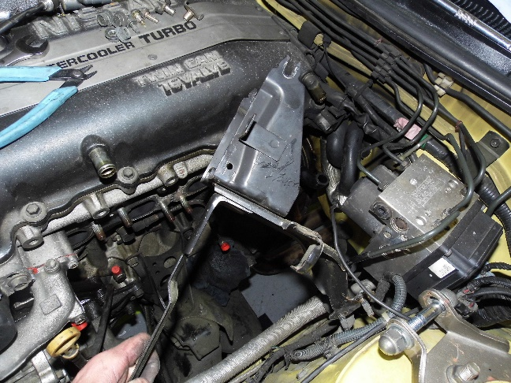

- Measure out 30mm from the factory bracket placement (this is where the bracket needs to be rewelded together after factory welds are cut)

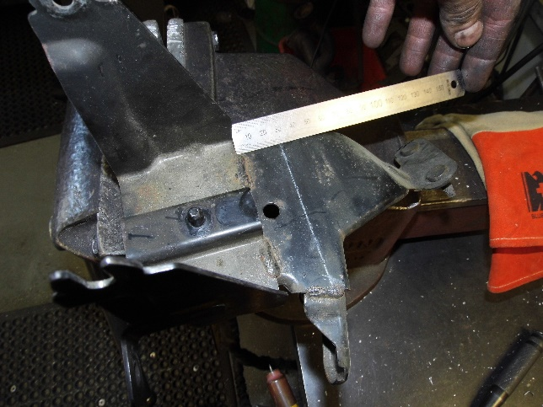

- Cut the stitch welds with a grinder and seperate the top and bottom sections, reweld the brackets where you have marked the 30mm offset

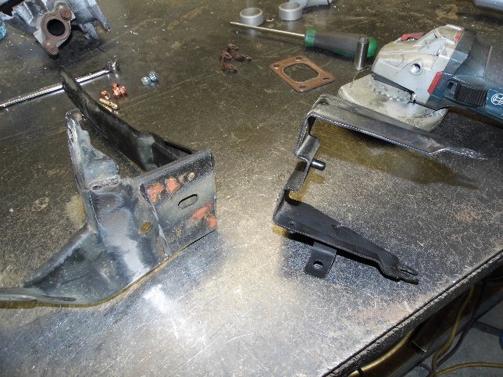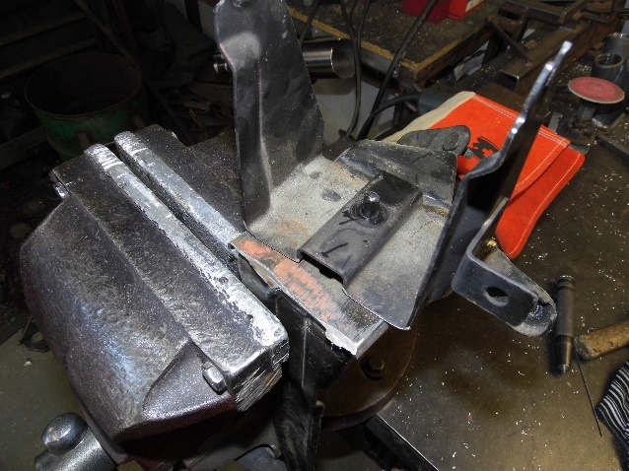

Bracket seperated Top and bottom part of bracket moved 30mm

- Paint the bracket and re-fit

- We do recommend using a heat shield to stop the heat of the manifold effecting the abs pump

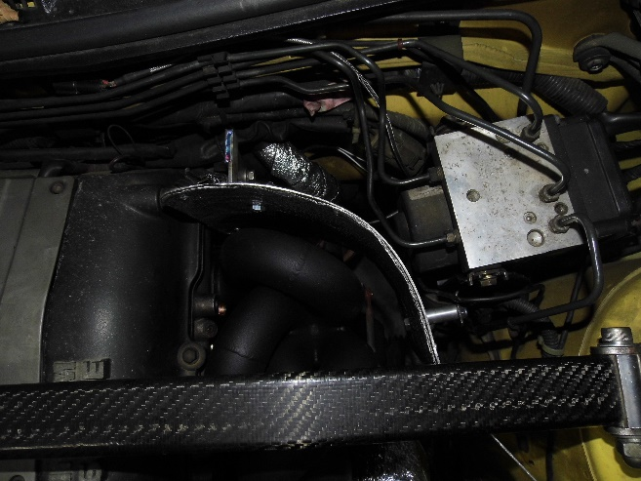

Section 2

Crankcase Breathers

- The rear crankcase breather needs to be turned towards the firewall for runner clearance, this can be done by removing the rubber hose and turning by either using a 3/8” extension and forcing lightly or tapping with a hammer, it is important to be careful or you will damaged the end of the steel tube

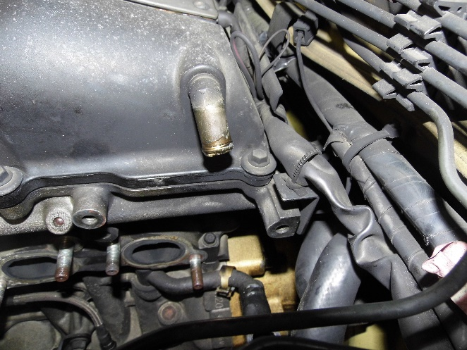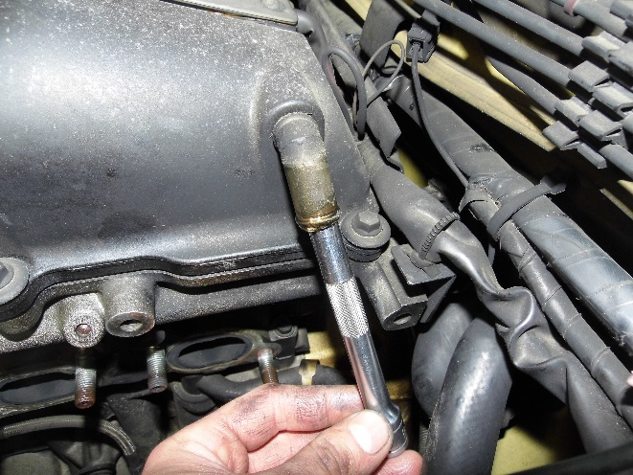

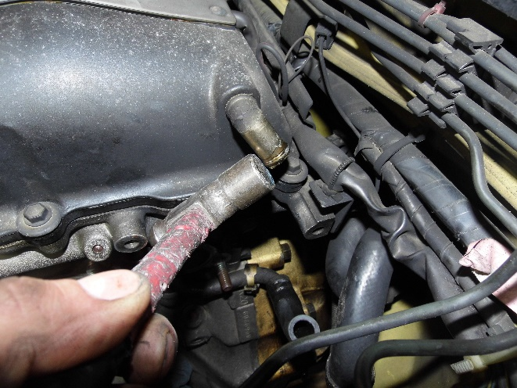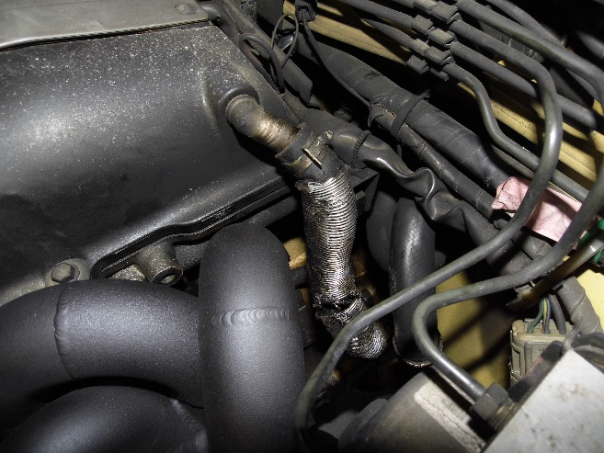

External Wastegate

- If you are running a external wastegate with abs, then the bracket needs to be taken out and the section in photo needs to be cut off and bracket re-installed
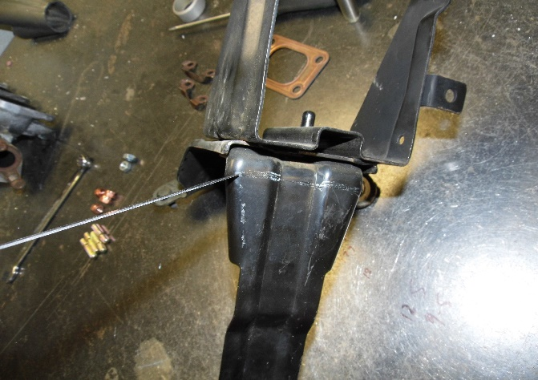

We recommend heat sleaving on the joiner for intercooler pipe

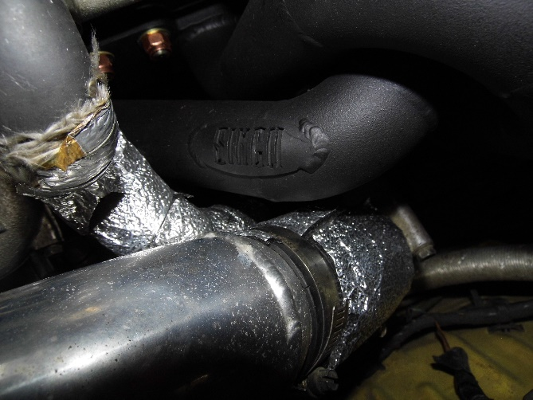

Extend the breather line that connects to the intake pipe by 40mm to give clearance from the manifold

